DigiCow Farmer Training Adoption Challenge – Script Documentation

This document provides a complete technical description of the ensemble machine learning pipeline implemented in the accompanying script.
- Overview & objectives

This script implements an ensemble machine learning method to predict farmer adoption of agricultural practices following training sessions. DigiCow supports smallholder farmers through digital tools and extension services, yet adoption rates remain low and uneven. This solution predicts the probability that a farmer will adopt a practice within 7, 90, and 120 days of training, using only information available at the time of the training event.
The challenge uses multi-metric evaluation: 75% Log Loss and 25% ROC-AUC. Given one training event record with farmer demographics, geographic location, trainer identity, and topics covered, the model outputs calibrated adoption probabilities for three time horizons optimized for both metric.
To address this dual objective, I propose a unified ensemble combining three complementary model families. TabNet provides attention-based feature selection with native categorical embeddings, LightGBM offers fast histogram-based splitting with minimal preprocessing, and XGBoost delivers GPU-accelerated training with strong regularization. Each model is trained with three random seeds and predictions are blended using metric-specific optimization: logit-space weighted averaging minimizes Log Loss, while Dirichlet random search maximizes ROC-AUC. Test-era feature alignment and cross-validated calibration ensure predictions reflect actual test-period conditions rather than historical training distributions.

Architecture diagram
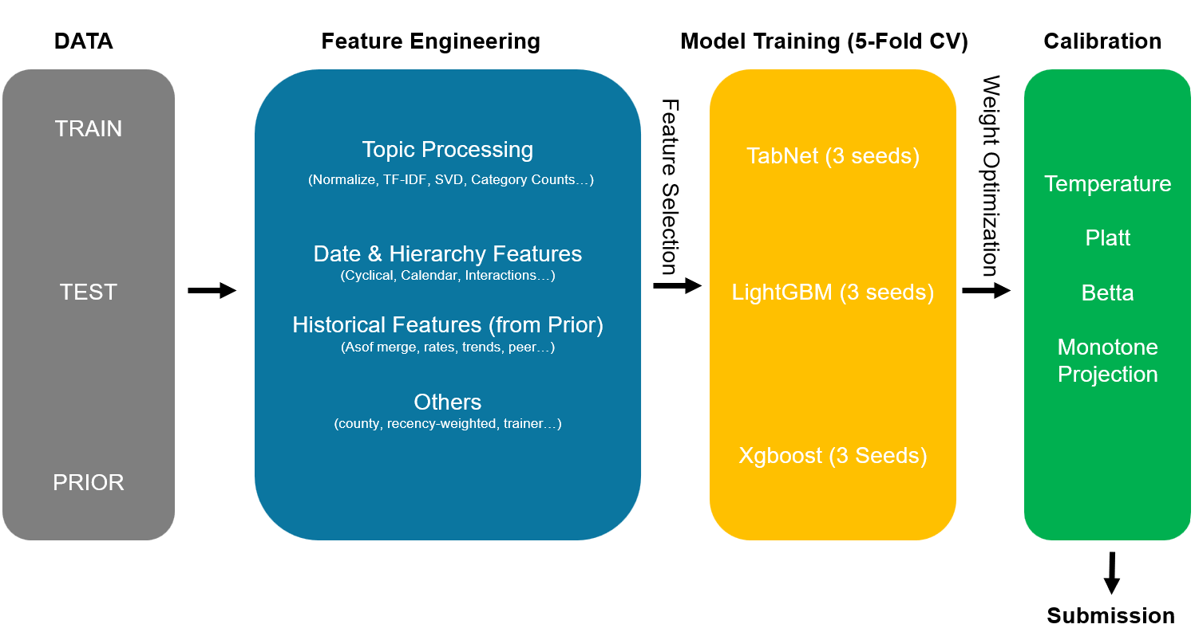
The model architecture follows a multi-stage ensemble design with temporal feature engineering, test-era distribution alignment, and dual-metric optimization (Figure 1).
Figure 1. Ensemble architecture for DigiCow adoption prediction.

ETL process (Extract, Transform, Load)
During the extraction stage, the pipeline reads structured metadata from Train.csv, Test.csv, and Prior.csv. Each row represents a training session with farmer demographics (gender, age, registration status, cooperative membership), geographic location (county, subcounty, ward, group name), trainer identity (stored as list-formatted strings), topics covered (nested lists requiring parsing), and adoption outcomes. For labeled data, three binary flags indicate adoption within 7, 90, and 120 days
The transformation stage builds temporal and contextual features from training timestamps. Date parsing generates datetime64 objects, then cyclical encodings capture seasonality (month sin/cos) and weekly patterns (day-of-week sin/cos).. Topics lists are flattened from nested structures, normalized (lowercase, trailing dots removed, whitespace collapsed), and processed through three pathways: keyword matching against predefined categories (poultry, dairy, health, feed, management, crops, shoats, biogas, finance), TF-IDF vectorization and SVD dimensionality reduction.
Historical features are constructed using temporal asof-merge operations with direction="backward" and allow_exact_matches=False to prevent data leakage. For each farmer, cumulative statistics include training count, adoption rates (cumulative and recent rolling windows), exponentially-weighted moving averages topic diversity metrics, and session gaps (seconds since previous session, expanding mean/std). Recency-weighted historical rates apply exponential decay (halflife=180 days) when computing county/trainer/ward adoption rates, ensuring recent events contribute more than distant history. Rolling window statistics (7, 30, 90, 180 days) capture short-term and long-term adoption dynamics for farmer, trainer, and group contexts using efficient binary search on sorted timestamps.
Test-era feature alignment addresses temporal distribution shift by computing adoption rates exclusively from prior events occurring after 2025-05-01 (the test period start). County/trainer/ward/subcounty test-era rates are merged as additional features, providing the model with ground-truth signal from the actual test distribution. Test-county-weighted base rates (weighted by test county distribution) serve as calibration targets rather than global train means, ensuring predictions align with actual test conditions.
Interaction features capture joint effects using target encoding with Bayesian smoothing (alpha=50): registration×county, cooperative×county, has_topic_trained_on×county, and age×county. Peer pressure features count adopters within the same group at each timestamp, compute peer adoption ratios, and track group-level adoption intensity. Trainer effectiveness features aggregate session counts, cumulative adoption rates, recent trends (rolling-30 mean), and workload (sessions in last 7/30 days). Geographic temporal trends compute cumulative and recent (rolling-20) adoption rates per county/subcounty/ward, exponentially-weighted rates (halflife=15), and trend signals (difference between recent and cumulative). Topic lift scores compute per-topic adoption rates with Bayesian smoothing (alpha=50) and lift ratios (topic_rate / global_rate), aggregated as mean/max/std across topics in each session.
During the load stage, features are combined into a unified labeled dataset by concatenating train and prior dataframes. A boolean train_mask distinguishes train rows (used for calibration fitting) from prior rows (used only for OOF evaluation to avoid double-dipping). Sample weights combine three components: temporal decay, adversarial weighting, and a 1.1× train boost factor. All weights are normalized to mean=1 for numerical stability.

Data modeling and architecture design
The ensemble combines three model families with complementary strengths: TabNet for attention-based feature selection, LightGBM for fast histogram-based splitting, and XGBoost for GPU-accelerated training with strong regularization. TabNet excels at learning sparse, non-linear interactions through sequential attention masks (entmax sparsity), handling high-cardinality categoricals via learned embeddings, and providing interpretable feature attribution. LightGBM offers fast histogram-based splitting, native categorical support without encoding overhead, and strong performance on tabular data with mixed feature types. XGBoost provides GPU-accelerated training (tree_method="gpu_hist"), robust handling of class imbalance via scale_pos_weight, and L1/L2 regularization to prevent overfitting on rare categories.
TabNet architecture: The network applies n_steps=5 sequential attention steps with sparse entmax masks to select features, producing n_d=64 decision features through independent and shared layers. Training uses Adam optimizer (lr=2e-3) for up to 300 epochs with early stopping (patience=40), incorporating L1 sparsity regularization and class-weighted cross-entropy loss.
Boosting architecture (LGB/XGB): Trees are grown with max_depth=7, regularization (L1=0.5, L2=15), and subsampling (0.7/0.75) to prevent overfitting over 10,000 rounds with early stopping. Class imbalance is handled via scale_pos_weight, with LightGBM processing categoricals directly and XGBoost requiring label encoding.
Ensemble blending: Log Loss blending optimizes weights in logit space via Nelder-Mead minimization (50 restarts) with numerically stable softmax normalization. AUC blending uses Dirichlet random search (8000 iterations) to maximize validation AUC, with final submissions using metric-specific optimal blends

Training procedure
Training is performed using 5-fold stratified cross-validation, stratified on binary target labels to ensure balanced positive/negative splits per fold. For each fold and each model type, three random seeds are used and predictions are averaged to reduce variance from random initialization and data shuffling.
TabNet training: Backpropagation uses Adam optimizer (lr=2e-3, weight_decay=1e-2) with ReduceLROnPlateau scheduler, training for up to 300 epochs with early stopping (patience=40). Batch size is 2048 with virtual batches of 512, applying class-weighted cross-entropy loss, gradient clipping (clip_value=2.0), and per-sample weights.
LightGBM training: Boosting uses 10,000 rounds with early stopping (500 rounds) at learning rate 0.03, processing categorical features directly without encoding. Sample weights are applied per-sample via Dataset weight parameter for both training and validation.
XGBoost training: Histogram-based tree construction uses GPU acceleration when available (tree_method="gpu_hist"), following the same schedule as LightGBM (10,000 rounds, early stopping 500, lr=0.03). Label encoding is applied to categorical features fitted on combined train+test data, with sample weights applied via DMatrix.
Feature selection: Stability-based selection trains LightGBM 5 times with different seeds, averages feature importance (gain metric), and retains the top 500 features plus all categorical columns. This reduces training time by ~3× while preserving categorical signal and reducing overfitting.

Loss function
Loss function: Model training uses binary cross-entropy with class imbalance addressed via scale_pos_weight (boosting) or class-weighted loss (TabNet). Sample weights modulate the loss to emphasize recent events (temporal decay), test-like samples (adversarial weighting), and train rows (1.1× boost).
Calibration: Candidate methods are evaluated using train-only validation log loss to avoid overfitting Prior.csv labels, with the best method selected automatically. Base rate alignment shifts predictions in logit space via Nelder-Mead optimization to match test-county-weighted target rates.

Validation and evaluation
Validation and evaluation: OOF predictions are aggregated across folds to compute global ROC-AUC and log loss, with separate train-only metrics reported to assess calibration quality without Prior.csv contamination. Test-era base rates are computed from prior events after 2025-05-01, weighted by test county distribution to address temporal shift between train (2024) and test (2025) periods.
Calibration evaluation: Four methods are compared—temperature scaling, CV Platt (logit regression), CV Beta (log-probability regression), and smooth ensemble—each evaluated on train-only log loss. The best method is selected automatically, with global refits on train-only data used for test predictions.

Inference and submission generation
Test samples are processed through all models, with predictions averaged across three seeds per model type and blended using metric-specific weights (logit-space for Log Loss, Dirichlet search for AUC). The calibration pipeline applies the selected method to LL-optimized blends (fit only on train rows), followed by base rate alignment to match test-county-weighted target rates.
The automated workflow generates submission_v15_ensemble_1.csv with six prediction columns directly compatible with the challenge evaluation system.

Runtime and environment
Full pipeline execution required approximately 10 hours on a Tesla V100-SXM2 GPU (TabNet) with CPU fallback for Catboost and XGBoost.

Error handling, monitoring, and maintenance
Missing columns are filled with defaults, categorical features use fillna("UNK"), and TabNet categorical index mismatches are validated before training to prevent CUDA errors. The pipeline prints per-fold metrics, calibration results, and submission statistics to verify alignment with test-era base rates.

Execution instructions
To run the pipeline, place Train.csv, Test.csv, and Prior.csv in the working directory. Update the working directory path in main() if your data files are in a different location. The script generates submission_v15_ensemble_1.csv with six prediction columns. All feature engineering, model training, calibration, and submission generation are automated. Seeds are fixed for reproducibility

Reported performance
This ensemble achieved a public leaderboard score of 0.969001938 and a private score of 0.961012524. Actual performance may vary depending on random seeds, hardware, and training duration.

